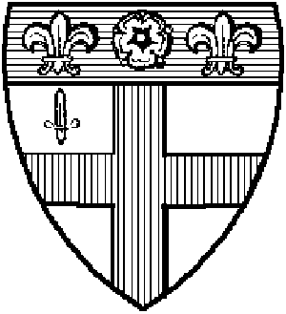 Friends of Christ’s Hospital

Friends of Christ’s Hospital

May 2005

The Board
Michael Allen
Jim Bell
John Doyle
Sally O’Brien
Patricia Stockton
Lance Reynolds
Peter Wood

FCH Governors
Grant Bruton
Iain McAra
Patricia Stockton
Peter Wood

Other US Governors
John Clay, Jeffrey Doyle, John Doyle, Judith Doyle
Peter Doyle, Andrew Fyfe, Derek Mumford,
Lance Reynolds

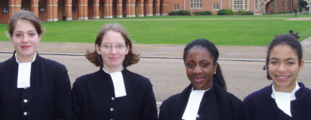
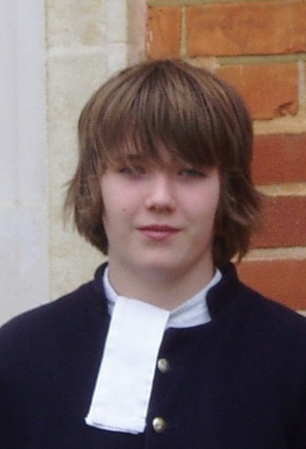

From One of “our” Children
I am really enjoying my second term here and the other girls in my house are too. None of us are really that homesick any more but there is one girl who can't contact her mum because she is in hospital. We're all trying very hard to make her feel better and she seems to be coping ok.
I guess in the first term, we were all out to impress and be popular. But now, we've all grown up a bit and we're just being ourselves. I've changed a lot since I got here, the clothes I wear, the music I listen to. I'm a lot more confident around new people now which has been a struggle for me. For now, all I can do is take each day as it comes and enjoy it as much as I possibly can.
Over the last term, I improved my grades from dropping three fours to dropping only one. Maybe this term, I'll get all fours and win a trophy for my house. We also won two awards and the house singing competition: best main song and best overall girls house. It was easier for us girls because there are less of us and so less competition.
I hate it in class when the girls and boys are divided in groups because there are eight girls and about twice as many boys. Plus, we could all get on so much better if we were allowed to work together. Quite a few of the boys are sexist and I intend to do something about that!
I also did a very brave thing by taking up cross-country running in the middle of winter! I was very proud of myself because I ran two miles in hail and nearly got hit by a train in the process! We have a steeplechase at the end of term so it's probably a good thing to practice.
Must go and tidy my room because the headmaster is coming round to check today.
Best wishes, Fayida

A Whirlwind Weekend: Senior Grecian’s Visit for Founder’s Day Dinner
November 4: Flight #19 to Newark; Greeted by Michael Allen holding The Blue; Tour of NYC including Ground Zero and Wall Street; relaxing evening chez Bell. November 5: Discovery tour of NYC, armed with a map and a Metrocard. Very welcoming Chaim Litewski gave a fantastic tour of the United Nations…a glimpse of Kofi Annan; wandered the streets of New York; a realization of the overpowering nature of its architecture; Empire State Building, Macy’s, Broadway, lunch on Times Square; unforgettable night at the Metropolitan Opera House – my first encounter with La Boheme. November 6: LaGuardia to Washington in Full School Housey! Private tour of the White House with Michael & Joan. Afternoon of Photo-Ops. The Mall, Lincoln Memorial, Korean War Memorial & the Capitol. Founder’s Day Dinner in the Cosmos Club. I gave a short after-dinner talk and did the best I could to answer various questions on CH history to current developments. November 7: Arlington Cemetery; JFK’s Eternal Flame; Veteran’s Parade at the Tomb of the Unknown Soldier. PM Train to Newark; Flight #28 to LGW. November 8: Surprise greeting from my Mum who had driven down from central London. Back to CH and lessons. Many many thanks to my hosts and Friends of Christ’s Hospital. Tamas Lorinczy.

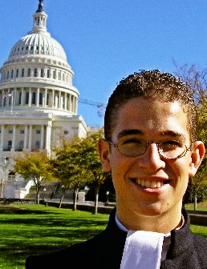
President’s Letter Friends of Christ’s Hospital is an American tax exempt 501(c)(3) charity with a board of seven volunteer Old Blue Directors (up from three in 2001) dedicated to “enriching the educational, cultural, literary and scientific heritage of Christ’s Hospital ….in the United Kingdom or in the United States”. A lot has been done in the last few years, and a lot more is coming. Our plans involve building the feeling of community here in the States, and creating frequent transatlantic cultural and educational connections. Let me share some recent and imminent highlights.

Keeping US Old Blues In Touch We are working with the school’s development office and the new CH Association to keep our database up to date. You can help enormously by letting us know (lancereyno@sbcglobal.net) or the partnership office (ptdir@chrits-hospital.org.uk) of any changes in your contact information, or that of your Old Blue friends. We have arranged with the school for all US Old Blues, for
whom we have correct email and surface mail addresses to receive all newsletters, publications of The Blue, and website contacts. We will keep you abreast of US programs through newsletters such as this one. We are also exploring web access so that Old Blues here can connect and interact. Our most significant community events are the annual Founder’s Day dinners; six of which have been held in the last four years. The 2005 dinner, to be held in New York on October 22nd promises to be our grandest and best attended yet. Set aside the date and watch for announcements from Jim Bell and Sally O’Brien.
Expanding The Transatlantic Connection We continue to fund student travel to the US, a revealing by-product of which is the ‘eye-opening ‘ effect on the student. For example the Senior Grecian, Tamas Lorinczy, visited New York and Washington in November of 2004 (see A Whirlwind Weekend ). He has since decided to spend three months of his gap year before going to university, traveling, studying, and interning (no not burying the dead!) in the States. Six Old Blues are helping host his American saga. A second major, and multi year initiative is to reestablish US/UK student exchanges such as the program that took some 45 American students to CH in the 50s and 60s.We believe that both CH and the students will be enriched in many ways by such a program. Another level of connection is being established by US Old Blues becoming Governors of the school, attending Court of Governors meetings, and taking part in the governance of the school and Foundation. At last count we were aware of twelve US based governors, four of whom are American by birth. Our congratulations to the three governors nominated in the last three months…Patricia Stockton, Peter Wood, and Grant Bruton. They join a body that has been graced by such illustrious names as Sir Isaac Newton and Samuel Pepys.
Providing Funding Support There is no need to remind Old Blues of this duty which is ingrained in all of us and to which US Old Blues have responded magnificently. FCH is the best, tax advantaged vehicle to support the school whether it is an annual cash contribution, a donation of stock, or designation in a will, foundation or trust. We will keep you informed on the best mechanics, and on specific programs that might attract your generosity.

In appreciation, and on behalf of my fellow directors; Jim Bell, John Doyle, Sally O’Brien, Lance Reynolds, Patricia Stockton, and Peter Wood, best regards to you all. Housey!

Michael Allen.

Financial Summary Our Chairman John Doyle donated $10,000 to FCH at our inception to cover legal expenses involved in incorporation and research to ensure that our practices would be in full compliance with IRS requirements. We have spent $8,000 of that and hold $2,000 in reserve. We have received subsequently, donations in cash and stock of $155,203 from 49 donors and two foundations. Since the beginning of 2002 we have made grants of $145,918 to the school. The majority, $128,750 has been directed toward the Building Fund. We have supported student travel such as the Band trip to the Rose Bowl and the 2004 Senior Grecian visit, and other student enrichment activities with grants of $14,713 to “The Tunbridge Beneficence”, a fund administered at the headmaster’s discretion. We supported the publication of Gordon van Praagh’s last book, A Fire to be Kindled, with $1,755 and contributed $700 to the Engineers’ Fund. In addition, in accordance with our zero overhead philosophy, Board members have spent approximately $5,000 of their own funds supporting Founder’s Day Dinners, mailings, conference calls and the Senior Grecian’s visit.

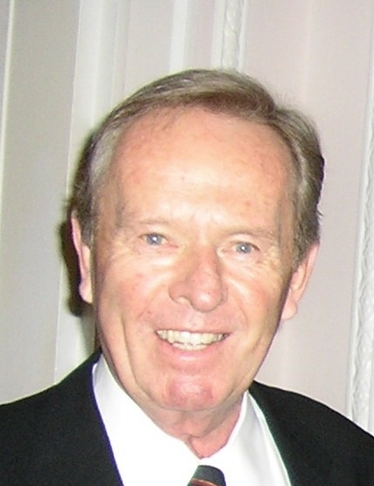

Thanks To All Twenty-first Century Donors

The names below include those who gave through BSUF or directly to the school.
Many of you have given on multiple occasions.

Michael Allen | Peter Hebben | Moyna Prince
Jane Armistead | Robin Hillyard | Alan Quaif (late)
Louie Atteberry | Bryan Hooper | Lance Reynolds
Bill Band | Geoff Hunt | David Robinson
Jack Boddington (late) | David Jeal | Doug Ruthven
Jim Bell | Richard Johnson | David Shears
Marianna Brose | Christine Kallmeyer | Ann Simpson
Alan Blackmer | James Keeley | Bill Sladen
Grant Bruton | Robert Kinloch | Vincent Sparrow
Chris Bugge | Philip Kitcher | Mary Sprague
Mel Churchill | Iain McAra | Mollie Stanner
John Clay | McBride Foundation | Paul Stephens
Gary Connelley | Maggie McCurry | Patricia Stockton
John Cottage | Ken McDonald | Summa Peto Foundation
Heather Day | JP Morgan Foundation | Richard Sydenham
John Doyle | Roger Moseley | Eric Taylor
Linda Drapeau | Garforth Mowll | Roger Thomas
Pat Esmiol | Derek Mumford | Sophie Till (Mooney)
Nigel Fleming | Kenneth Northcott | Trevor Tomkins
Margaret Fuhro | Sally O'Brien | David Van Wyck
Anthony Furnivall | Peach O'Gorman | Pete Wiggins
Andrew Fyfe | Bill Patterson | Peter Wood
Alice Godfrey | Theresa Perlis | Debbie Wright
Clem Hastie | Jane Phelan | Henry Young

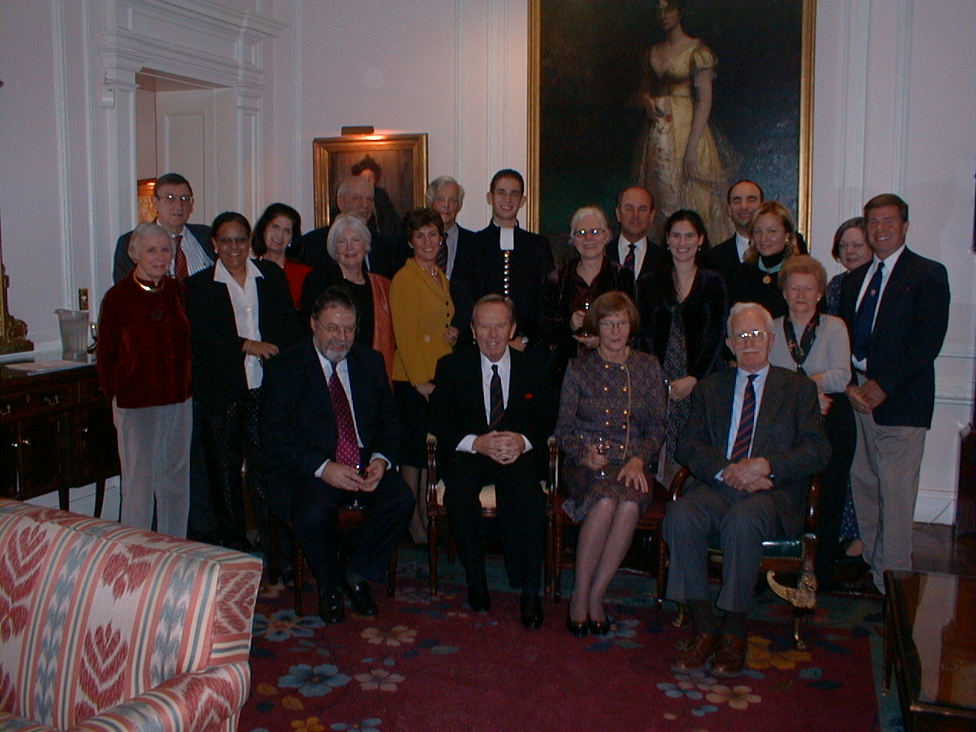

In Memoriam Alan Quaif, Middleton B, 1933-1938. Died at his home in Marietta, Georgia, on March 9, 2005. His family played I Was Glad and Jubilate Deo from the Christ’s Hospital Celebrates 450 year CD at his Memorial Service.

Competition Can you name the following US Old Blues? a) He flew jets for the RAF, b) She flies retired greyhounds to new homes, c) He has a mountain named after him in Antarctica, d) The chemistry professor who has sung in all Gilbert and Sullivan operettas? Sender of the first correct answer to lancereyno@sbcglobal.net will receive Christ’s Hospital, The Last Years in London, by CME Seaman.

Founder’s Day Dinner, Washington
How to Make Donations to Friends of Christ’s Hospital
A Cash Gift Made by Check Checks should be made payable to Friends of Christ’s Hospital and sent to Lance Reynolds, 470F Cola Ballena, Alameda, CA 94501.
A Corporate Matching Gift Friends of Christ’s Hospital can accept all tax-deductible contributions from corporate matching gift programs. Our Federal ID number is 91-2162264 and our California Corporation number is 2350816
A Gift of Securities A gift of appreciated securities or property may offer significant tax advantages. Instruct your broker to transfer the stock using these DTC Delivery Instructions:
Piper Jaffray's DTC Clearing Number – 311, Reference 3483-3615 Friends of Christ's Hospital
Please also notify our Piper Jaffray representative in Menlo Park, Josephine Laporte, 650-838-1440 or Josephine.x.laporte@pjc.com so that she can watch for its arrival and notify us.
Questions
John L. Doyle, Chairman, Friends of Christ’s Hospital, 177 Ramoso Road, Portola Valley, CA 94028. 650-851-7707 twoj@vincamanor.com
Michael Allen, President, 8 Wright St., Westport, CT 06880, 203-656-1040 MikeA@mac-island.com
M. Lance Reynolds, Secretary/CFO, 470F Cola Ballena, Alameda, CA 94051. 510-841-1942 lancereyno@sbcglobal.net

If not deliverable please return to

Friends of Christ’s Hospital, 470F Cola Ballena, Alameda CA 94501

